Little Gem Arts & Crafts Gallery

Newsletter Number 7 – September 2020

ANOTHER BUMPER EDITION WITH FEEDBACK FROM THE SURVEY,
PLANS FOR RE-OPENING AND LOTS MORE!
PLEASE READ CAREFULLY

I hope that you are all still well, keeping safe and still observing all the Government Guidelines.

For the rest of the lock-down period, until we get together again, if you need any guidance or advice about your painting, or if you want to discuss anything, such as the re-opening, please don’t hesitate to contact me by email srwilkinson1953@gmail.com or phone 077 22 234 752.

Little Gem Committee Meeting

We held our second post-lockdown Little Gem Committee Meeting on Tuesday.
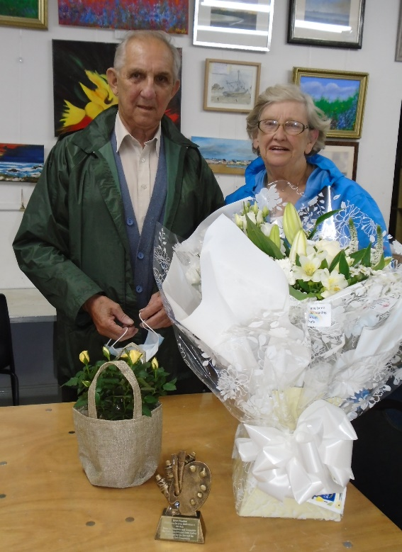
At the meeting, we presented Lilian with a bouquet of flowers and Brian a lovely trophy as a thanks, from the committee and all the members, for all the hard work which they have put in over the years. We look forward to continue working with them, albeit in a much reduced capacity as they start to take things a bit easier.

Having formalised Brian and Lilian’s resignation, the Trustees elected the new charity officers. For now, until we can get more people involved as Trustees and/or the organising committee, I shall be fulfilling the roles of Chairman and Treasurer and Sue will continue as the Secretary. David will also continue with his invaluable support on legal matters, in pursuing grants and running the social media for the Gallery.

Lilian will continue to look after the finances until the audit is completed and then hand over the accounts to me. She also intends to continue with the Wednesday afternoon craft club. Likewise, we are pleased to know that Brian will continue to play a leading part with the Childrens Club (once suitable arrangements have been made) and, subject to the COVID provisions, will complete the watercolour classes which he was in the middle of when the lockdown started.

We will be approaching some members to see if they are interested in helping in the running of the Gallery. We will be looking to recruit new Trustees to serve from 1 – 3 years (at their discretion) and for committee members and sub-committee members (more later). Remember; the Trustees shall oversee the operational committee which shall comprise both Trustees (should they wish to participate) and other invited members. All day-to-day activities of the charity shall be delegated to the committee which will be managed by the chairman, the treasurer and the secretary. That way, we can ensure that the charity is run “by the members for the benefit of the members and the local community”.

I will circulate a description of the roles of the Trustees and of the committee members (as soon as I can write them) to give you an idea of what the roles entail. Then, if you are interested in becoming a Trustee and/or joining the committee, please contact me (srwilkinson1953@gmail.com or 077 22 234 752). Please do this before the 14th September so that we can get things in place for the next formal committee meeting on 29th September.

We also discussed and ratified our plans for re-opening; details below.

Re-opening Survey

Thank you very much to all of you who responded to this survey. It has allowed me to sort out a rota for the re-opening of the painting workshops (see below). Additionally, your comments will help the committee to shape the charity and the Gallery as we go forward.

Little Gem Shop

As part of the ‘Deep Clean’ and tidy up of Gibson Street being carried out before the re-opening for workshops, we will be re-locating the shop into the area behind the current counter. Val will be helping to improve the display and present the goods to the shoppers in the best possible way.

Until further notice, the shop will initially only be open during the planned workshops (see below). Thereafter, assuming that we can get volunteers to ‘man’ (or ‘woman’?) the shop, we will be opening at times (to be agreed) over the weekend too.

Alternatively, if you have any immediate requirements which you cannot obtain locally, please let me know and I can see how I can help you.

Gibson Street Deep Clean

As a pre-requisite to the re-opening, (amongst lots of other things) we need to undertake a thorough deep clean of the Gallery. While doing so, we will be taking the opportunity to tidy up the facilities and make some changes and improvements. We have put together a plan of what needs doing (appended at the end of this Newsletter). But the current reduced-size committee really need your help to do all this work.

If you can spare some time, either ad hoc or on a regular basis over the next few weeks, we would really appreciate all help which you may offer.

So, if you would like to help to produce an environment which better helps us run our workshops, as well as projecting a better image to the community and potential customers, please get in touch with me on srwilkinson1953@gmail.com or 077 22 234 752

As we will be limited in the numbers which we can have safely working together, I will produce a rota matching your availability and we can work together to produce the ‘new’ gallery.

Little Gem Workshops

We shall be re-commencing the workshops on the conditions detailed in my email of 18th August. If you need these details and have not received them by email, please contact me and I can provide the information.

We plan to open the workshops commencing on Tuesday 15th September (subject to getting all the cleaning and reorganisation done in time!).

To comply with regulations and Government guidelines, workshops shall be restricted to a maximum of 6-8 attendees, all wearing face masks, using hand sanitiser on entry and when needed, and members bringing and using your own materials and equipment. Only paper, canvasses and water (if required) will be provided by the gallery.

The rota for painting workshops, derived from the survey responses, is given below. If it doesn’t reflect your preferences as expressed in the survey responses and subsequent discussions with me, please let me know. Sue will soon be sorting out the rotas for the craft sessions. As the last course has finished, the rug-making classes will not be re-started during the present restrictions. However, if and when the demand necessitates, we will review that decision (subject to the current restrictions being lifted). The East Coast Art Club will also be making arrangements to re-start their Wednesday evening sessions and advising their members accordingly.

If you have decided that you are not quite ready to join these workshops, please let me know if, and when, you are comfortable to join us again and I will revise the rota accordingly.

Additionally if you know of someone who may be interested (but who wasn’t on my email distribution list), please ask them to get in touch with me to make suitable arrangements. Please spread the word that we are re-opening and that the needs of all artists, previous attendees and new, will be catered for (subject to availability of spaces in the sessions).

You will all be pleased to hear that Keith is coming back to help run the workshop sessions. To start with, he will be ‘looking after’ the Tuesday morning oils workshops. This will leave me to run the Wednesday morning and Thursday sessions. But Keith will be considering whether he can help here too.

Once we get going, we will see if we can open up more sessions. If Keith, or I, cannot make these additional slots, it would really help if we can get volunteers to act as leads to open up the gallery, to ensure that we are following the prescribed procedures and to collect the fees. There would be NO requirement to provide any tuition, only to help in the administration of the workshops. So, you don’t have to be a brilliant tutor like Keith to give us a hand! Again, I would love to hear from anyone interesting in helping out in this capacity.

Remember, your health and safety is our greatest concern and we will support you as best we can to get back to our social gatherings and produce some more fantastic paintings.

The draft rota for the initial few weeks of re-opening is as follows:

Day: | Tuesday | Wednesday | Thursday | Thursday
 | ‘Oils’ | ‘Acrylics and Watercolours’ | ‘Acrylics’ | ‘Watercolours’
Time: | 10-12 | 10-12 | 10-12 | 1 - 3
Diane
Eva
Brian D.
Rita
Sara
Fiona
Joan
Sue
Valerie
Yvonne
Elizabeth
Janice
Ronnie
TOTAL | 6 | 6 | 5 | 5
KEY:
Oil
Water
Acrylic

The allocation of type of painting, as shown in the three colours, is nominal and, if you really wish, you can do other media instead. However, as you can see, the Tuesday and Thursday sessions have worked out well as (water-based) oil, acrylics and watercolours respectively.

Gallery Exhibition Sub-Committee

In response to feedback from the members in my original quick survey and the later re-opening survey, we are changing the way that we support artists to exhibit and sell their artwork via the gallery. Initially we will be reducing the number of paintings hung in the gallery to improve the visibility and profile of those paintings exhibited in the gallery. We will need to place a limit on the number of items which an artist may exhibit at any one time.

For those who have paid to exhibit your artwork or craftwork; we need to take account of the loss of selling opportunities during the lockdown. So, we are extending this year’s June-to-June renewal fees until the end of the year. So effectively, for those exhibiting already, it will be free until the end of the year. So every renewal will be due on 1st January 2021 and subscriptions will then run January-to-January. Anyone new signing up and starting to exhibit will get an extra three months for their yearly subscription. So, for their first year’s subscriptions, they will get exhibition until the end of 2021.

This will require some organising and for the setting up of an exhibition rota. To achieve this, we are proposing forming a Gallery Exhibition Sub-Committee who will be responsible for establishing and implementing the guidelines for exhibition. If you are interested in joining me on this sub-committee, please get in touch. I doubt whether this activity will be very time-consuming, so don’t be put off from volunteering!

Additionally, it would make sense that this sub-committee would also take the lead in arranging our annual formal exhibitions.

Little Gem Logo

At the committee meeting we reviewed all submissions which we have received for the logo competition.

Taking full consideration of the input which I received from you all about the logos included in the last Newsletter, we voted and selected the following logos to be used in the future.

The prize for the winner has been re-donated back to the Gallery for future use.

Northumberland Lottery

Don’t forget to join in with the Lottery and encourage your friends too. For more information visit: www.NorthumberlandLottery.co.uk click on ‘Buy Tickets’ and search for The Little Gem Arts and Crafts Gallery.

Little Gem Virtual Gallery

We currently have well over 142 paintings exhibited from 11 artists.

You can visit the virtual gallery by going to:

https://www.artsteps.com/view/5e8db2dd01608162e13d9d60

and the 2nd gallery by going to:

https://www.artsteps.com/view/5ef9b5ea8edcb11c650a4e54

The Sunflower Project
Once we have re-opened the workshops, we will be ready to exhibit your paintings produced for the SAA’s Sunflower Project in our window. Please bring them along at any time that the gallery is open (see rota above), or contact me and I will pick them up from you.

The SAA campaign itself is open to anyone, whether you are a member of SAA, or not. Visit the SAA website https://community.saa.co.uk/ or click on the buttons below to either enter the challenge and/or view the gallery of entries

ENTER CHALLENGE View Gallery of Entries

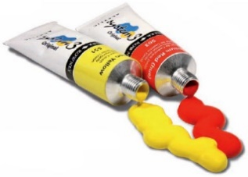

Stay safe and healthy!
Steve Wilkinson
srwilkinson1953@gmail.com
077 22 234 752
28th August 2020

Little Gem Art & Craft Gallery Charity Number 1163002

Committee members:
David Sinclair
Christine Davison
Sue Case - Secretary
Steve Wilkinson - Chairman and Treasurer

If you do not wish to receive further mailings from Little Gem, please click here.

Little Gem Gallery – Work Required before Opening (draft)

- Temporarily stack tables in workshop area
(leave 2 or 3 for temporary storage away from walls)
- Clear out windows and temporarily store (onto tables)
- Clean windows and display area
- Clean and replace displays in window (to be revised later)
- Remove paintings and wall hangings from walls and store carefully
- Clean walls in workshop area and paint where required
- Temporarily move bookcase and books into workshop area (books stored in shelves in back room)
- Temporarily move desks and contents into workshop area
- Clean wall and floor behind counter
- Temporarily remove crafts from counter
- Clean counter and floor beneath and in front of counter
- Replace counter (possibly re-locate)
- Remove shop goods from back room and store in boxes, ready for stocktake
- Re-locate shelving from back room to wall(s) behind counter
- Stocktake - and replace shop goods on display in new shop area
- Temporarily re-locate workshop materiel from ‘bookcase’ in back room
(onto tables in workshop area)
- Empty rest of back room (sort out junk and temporarily store rest on tables)
- Clean floor and wall of back room – paint where required
- Clean desks and bookcases
- Re-locate desks and bookcase(s) in back room
- Replace workshop materiel and books in bookcases in back room
- Procure storage shed for items storage outside in back yard
- Sort out and remove stored craftwork to back room/shed (in boxes)
- Re-stack all tables in front of counter
- Vacuum floor in workshop area
- Re-distribute picture hanging wires (hanging sub-committee)
- Clean and re-hang current paintings (ready for rota at later date)
- Clean tables and re-locate in workshop area.

  - Workshop area available for workshops 14th September 2020

- Clean toilets and refurbish
- Sort out junk in kitchen and surrounding areas – throw away, or store neatly
- Iteratively clean (and re-clean as required) rest of kitchen and back rooms.

  - Toilets, kitchen and back room proclaimed ‘in bounds’ for members
5th October 2020

